Bridget Brinkman

Professor Flynn

ENGCMP 0610

3 June 2024

Creator Statement: Introduction and Reflection

**Introduction:**

My visual argument is a recruitment advertisement for my guild on World of Warcraft Classic: The Burning Crusade. To participate in high-end PvE content, a group of 25 players is required. Recruiting and retaining players is crucial, so my goal is to create an engaging advertisement to attract applicants. My guild has defeated four out of six bosses in Sunwell Plateau, the current raid tier, so I decided to depict the bosses as the backdrop to my message. I desaturated the images of the last two bosses to incite an emotional reaction in players, motivating them to join us in our goal: to work together, have fun, and defeat more bosses!

**The Editing Process:**

At the start of the project, I began working with small thumbnails. After equally spacing thumbnails, I intended on placing informational text above and below. I wanted to combine images and text for the most impactful delivery of information. This design concept would hold the bosses at the core centerpiece of the image and convey the intent and goals of my advertisement through imagery to prospective applicants.

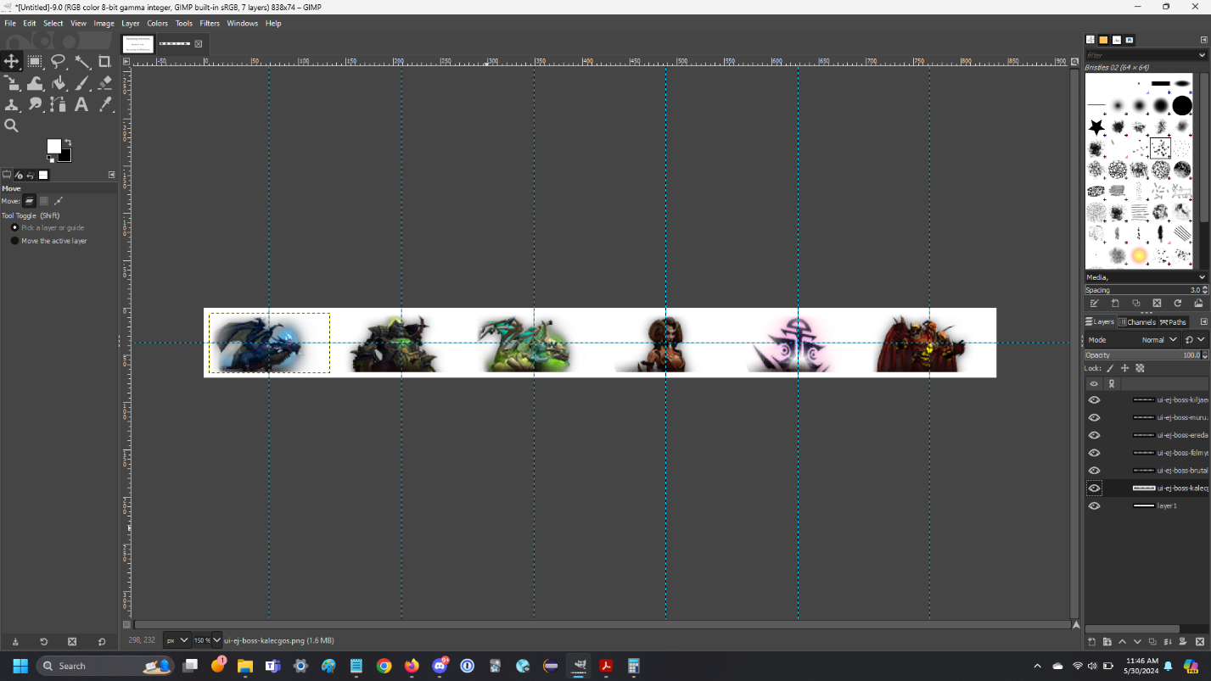

I began to work with the saturation slider for each individual layer. The slider gave me control over the amount of desaturation per image. Since the images already had such nice, vibrant, and unique colors, I experimented with 80% desaturation, to convey the feeling that my group had already defeated most of the bosses, while still letting some of that beautiful original color shine through.

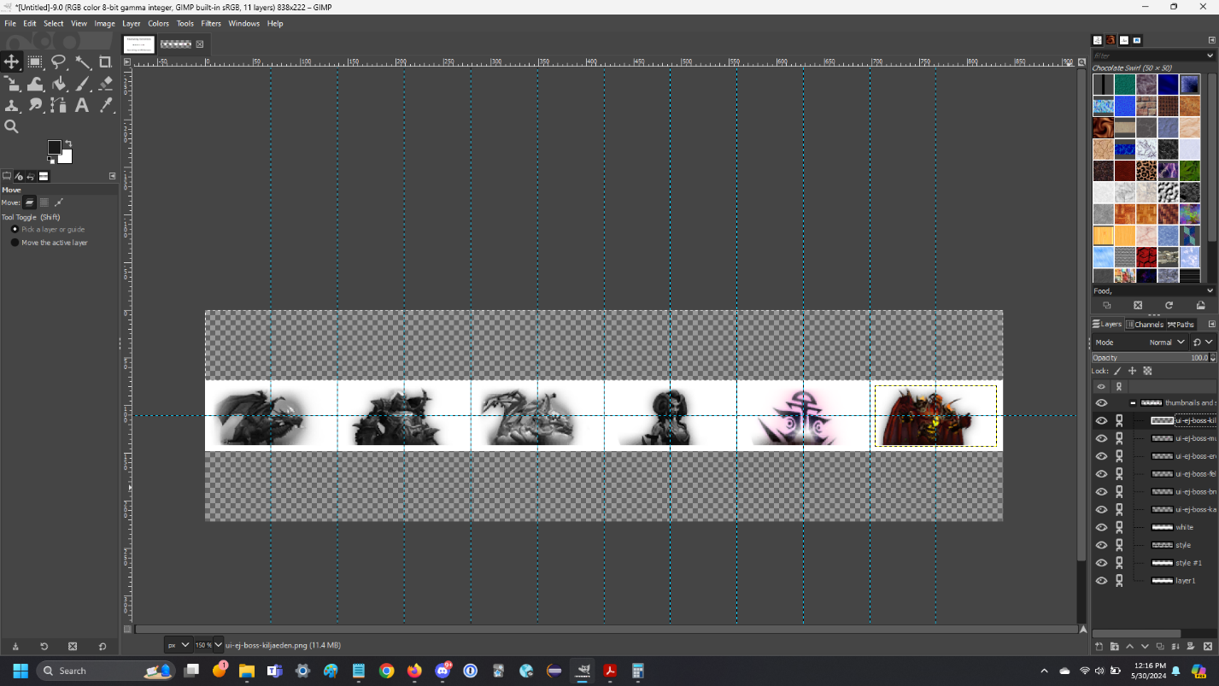

I began testing different fonts, placements, and sizes.

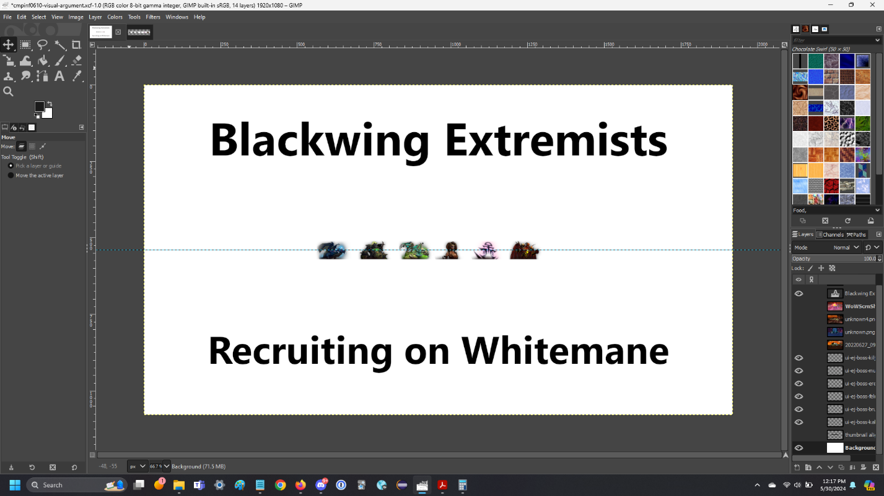

I moved forward with a similar yet different design concept, using in-game screenshots captured by players and uploaded to [Wowhead](https://www.wowhead.com/tbc). This would allow my images to serve as a backdrop and allow my informational text to serve as a centerpiece. I utilized guidelines, alpha layers, and masking techniques to space my images. I flipped the top right image 180 degrees to face center, directing the focus of each boss’ face toward the text I would place in the center, thus directing viewer’s eyes.

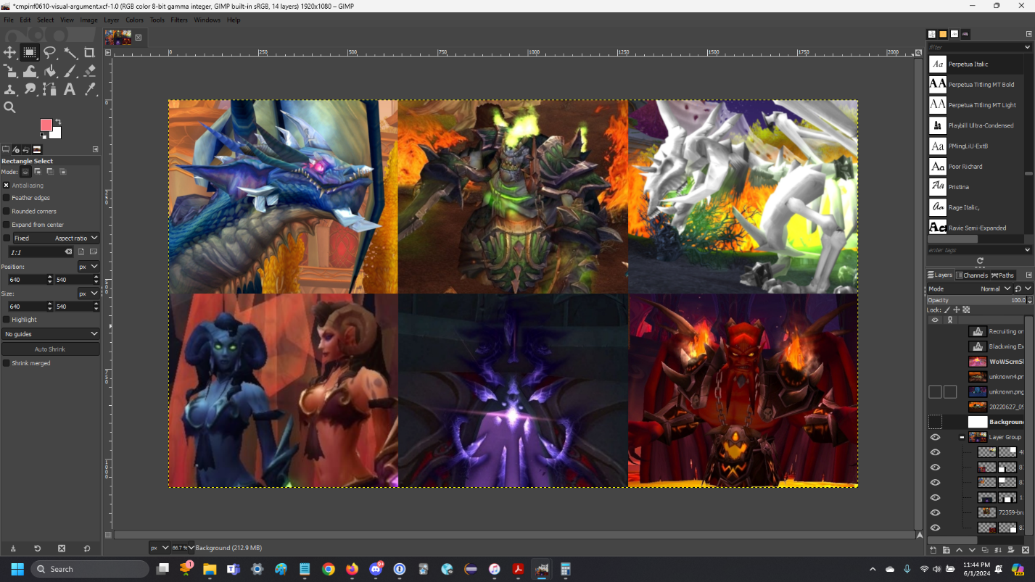

I worked on placing, aligning, and sizing text.

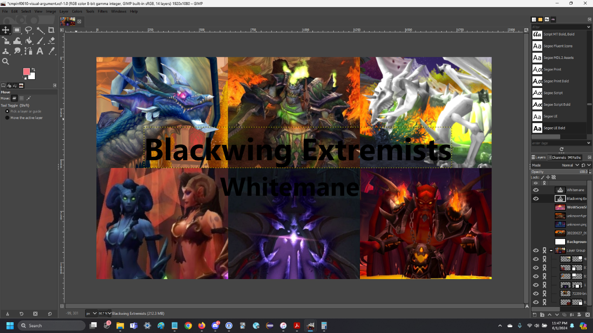

Partial desaturation and a text gradient effect.

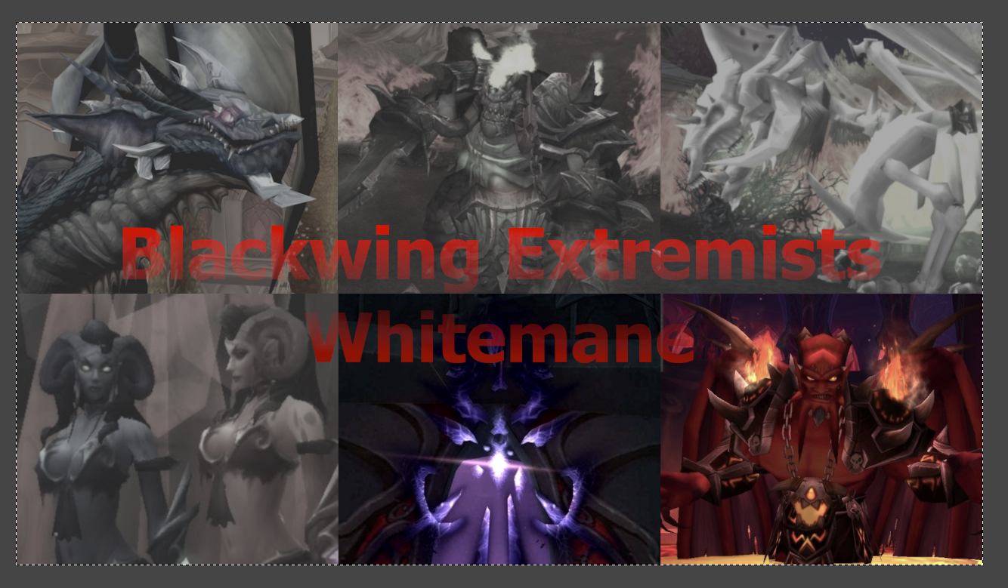

Changed text color, font, sizing, placement.

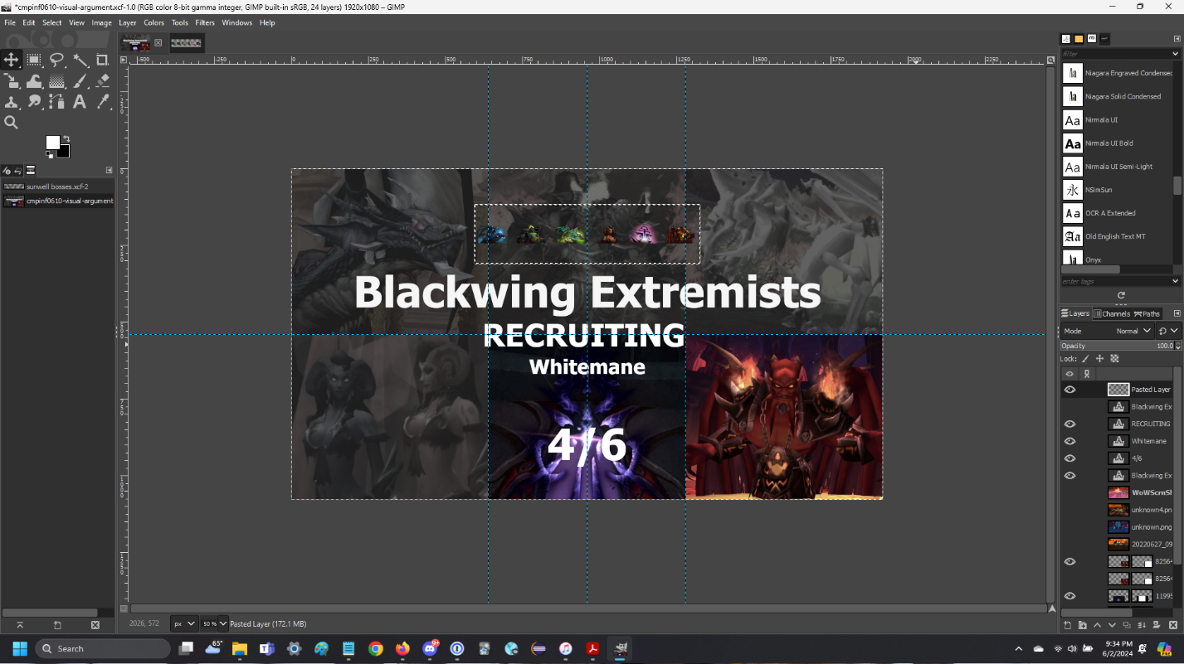

At this point I was unhappy with the bleak, sad, gray feel of my image. I decided to try the inverse:

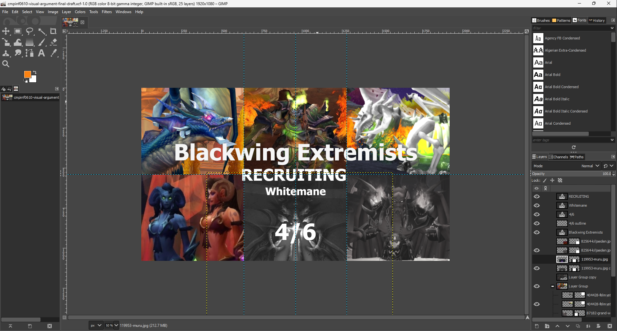

The inverse looked much better! A lot more vibrancy, excitement, and life!

**Final draft comparison:** I decided to go with Option 1) because it incorporated the amazing vibrant colors of the game, along with conveying my urgent message to potential applicants: that we are recruiting to take on the final two bosses! I felt the saturation slider and grayscale effect that I applied to the final two boss screenshots conveyed my intent and worked to persuade applicants through color vs. grayscale contrast rhetoric.

Option 1) *winner! A nice balance of color and grayscale to convey a rhetorical message*

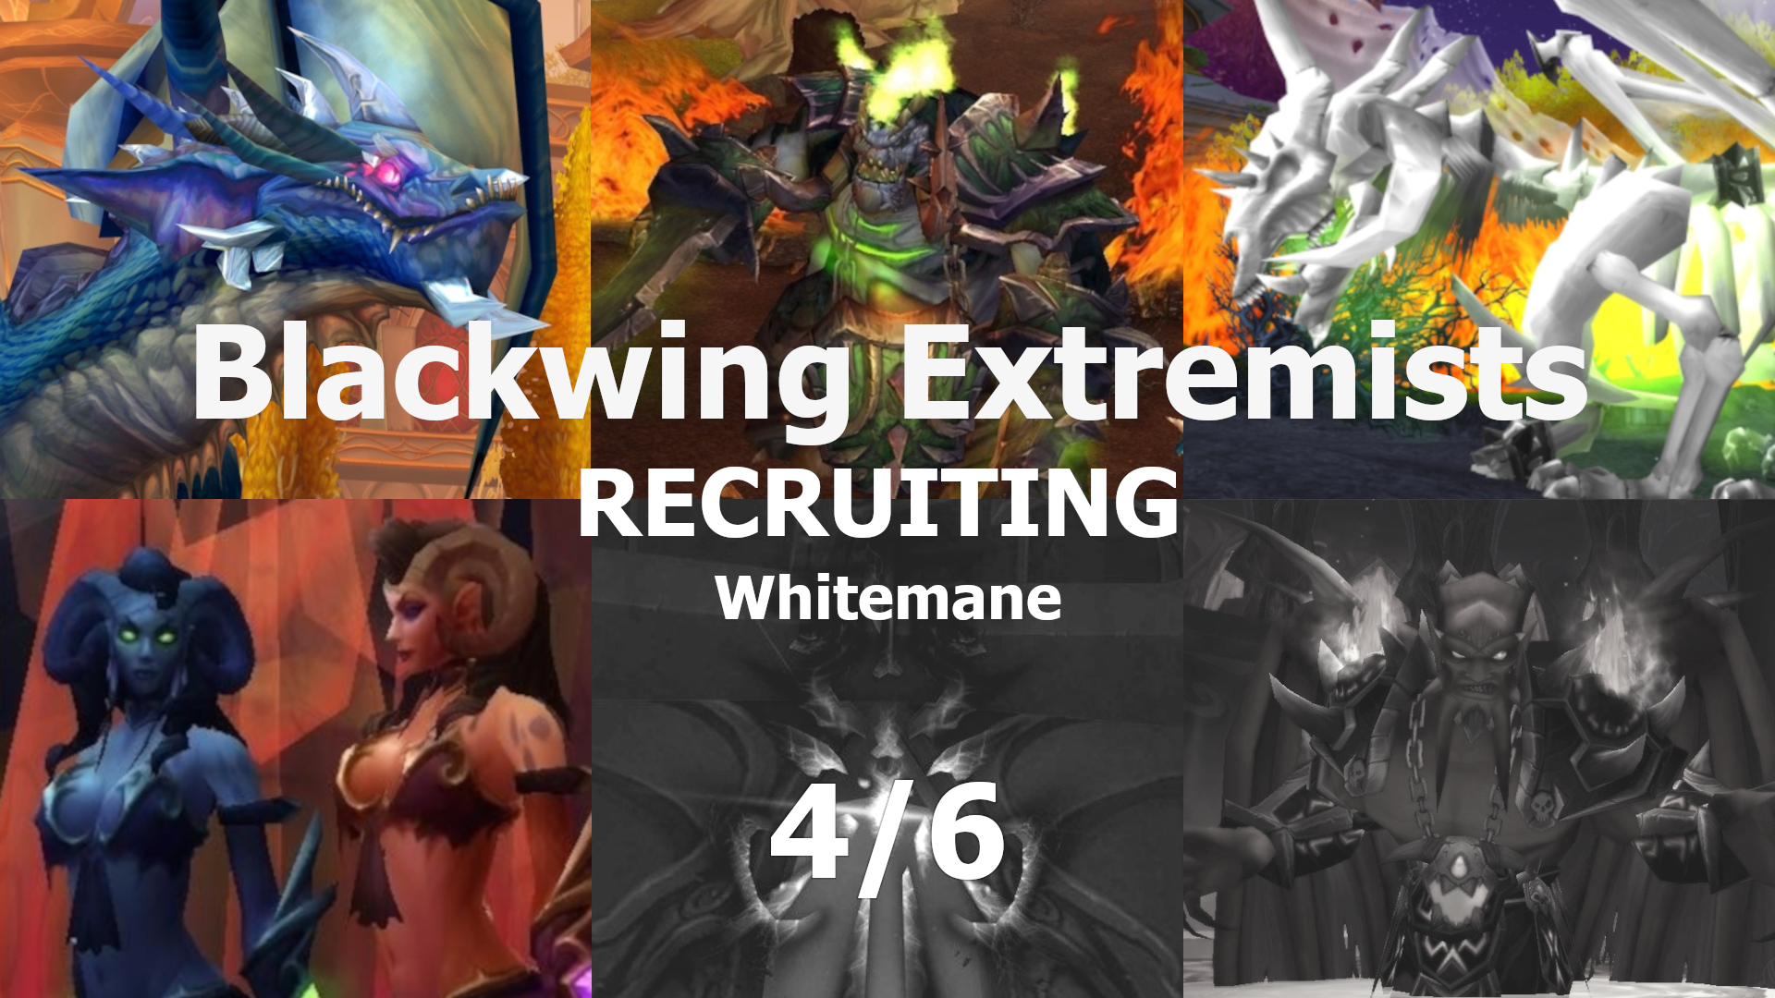

Option 2) *too much grayscale, leading to a bleak, boring, sad feeling*

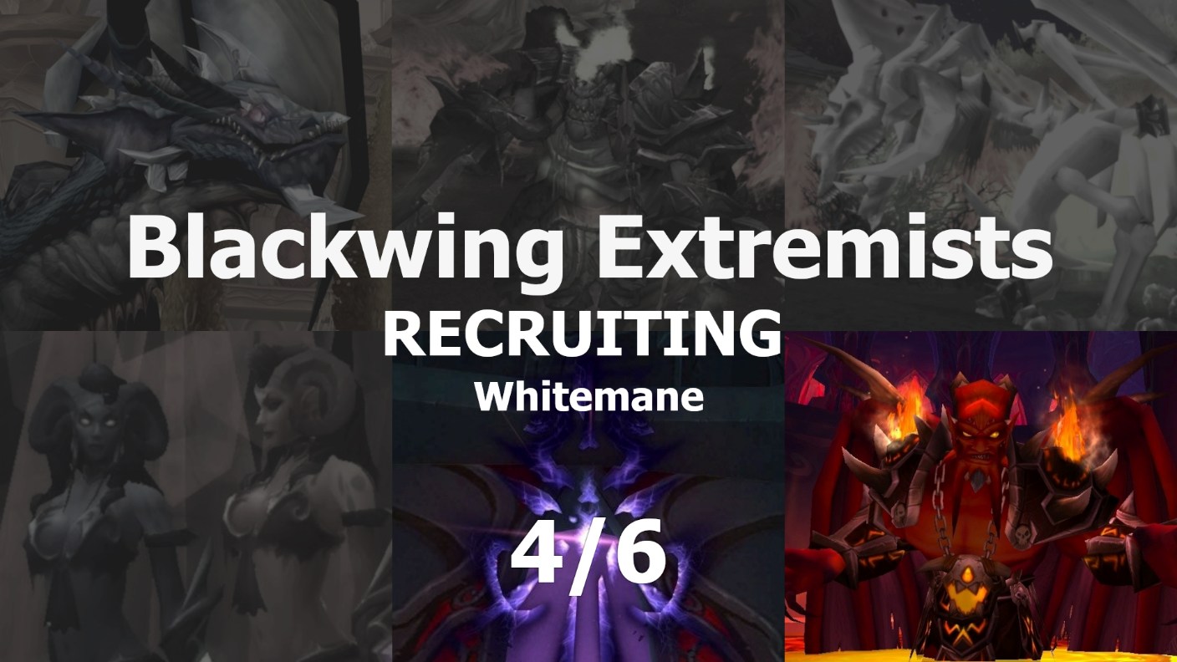

Option 3) *too much color, doesn’t convey much of a rhetorical message*

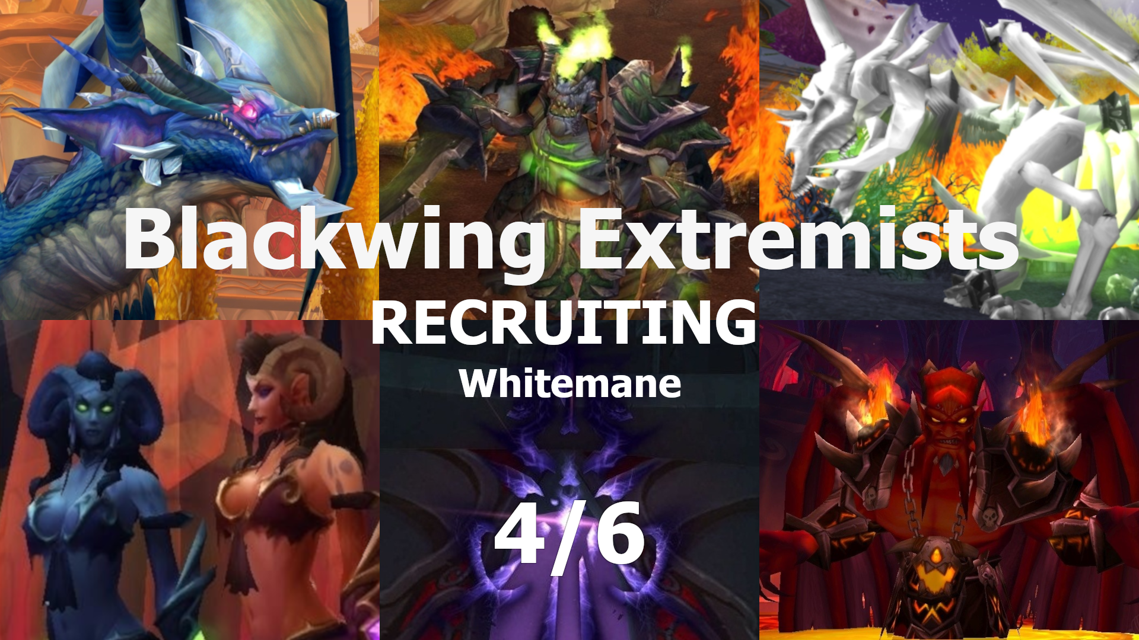

**Reflection:**

My main rhetorical goal was to create an image to attract and persuade players to apply to my guild, the Blackwing Extremists. I focused on depicting the bosses from Sunwell Plateau, the main game content that my guild focuses on, as the backdrop for my text message. The centerpiece of my advertisement is my guild’s name, our server, our progress, and the word “RECRUITING” in all caps. I depicted the final two bosses that my guild has yet to defeat in grayscale to emphasize our goals to potential applicants. Since I plan to advertise on online platforms such as the official Blizzard forums, Reddit, YouTube, Instagram, and Twitter, I designed the image with a specific layout and size. My intention is to hype up my target audience and incite a desire to take on epic adventures and gameplay with us.

The main design concepts I used were balance, contrast, repetition, alignment, proximity, power of faces, and the picture superiority effect. For balance and repetition, I equally spaced and sized screenshots of each of the six bosses. I offset the image-based backdrop with centered, white text that spelled out my main message. Through the power of faces, I symmetrically placed the bosses and rotated the images so their faces pointed toward the center, where my text lies. The image makes use of proximity, with the text taking a medium area of real estate in the center of the overall image, and the backdrop consisting of vibrant pictures of bosses. I contrasted the bright colors with grayscale for the two undefeated bosses to emphasize and push a sense of desire for viewers to join my group and help us defeat all bosses.

I used numerous GIMP tools to help me achieve my message. I used guidelines by percent to space out the organization of my image and to help me center objects. I used the rectangle select tool to create an alpha channel and add a layer mask, allowing me to temporarily "crop" each boss image to fit inside its designated area. This method allowed me to reposition the images as desired without making permanent changes. I learned the importance of always making duplicate copies of each original layer, enabling me to experiment with changes while preserving the unaltered originals. This way, I could always start from scratch with the original if I was not happy with my changes. To create a professional look, I kept my image symmetrical, brief, clean, and sharp. Additionally, I altered the brightness and contrast to ensure a cohesive tone across the entire background.

By applying these design principles through the tools in GIMP, my aim was to create a compelling and engaging visual argument that would resonate with my target audience. My goal was to communicate my guild’s objectives and current progress and to persuade players to join us in our endeavors and adventures.